**DAILY ONLINE ACTIVITIES SUMMARY**

|  |  |  |  |  |  |  |  |  |
| --- | --- | --- | --- | --- | --- | --- | --- | --- |
| **Date:** | **23/05/202** | | | | | **Name:** | **Anjali Manohar Prabhu** | |
| **Sem & Sec** | **4th Sem Section - ‘A’** | | | | | **USN:** | **4AL18CS007** | |
| **Online Test Summary** | | | | | | | | |
| **Subject** | | **Data Communication** | | | | | | |
| **Max. Marks** | | **30** | | **Score** | | | **23** | |
| **Certification Course Summary** | | | | | | | | |
| **Course** | **CLOUD FOUNDATION** | | | | | | | |
| **Certificate Provider** | | | 1. **Great Learning Academy** | | **Duration** | | | **3.5hrs** |
| **Coding Challenges** | | | | | | | | |
| **Problem Statement:** 1. Write a C program to implement SRTF process scheduling. | | | | | | | | |
| **Status: COMPLETED** | | | | | | | | |
| **Uploaded the report in Github** | | | | | **Yes** | | | |
| **If yes Repository name** | | | | | [**https://github.com/vinisharen/lockdown-coding**](https://github.com/vinisharen/lockdown-coding) | | | |
| **Uploaded the report in slack** | | | | | **Yes** | | | |

Online Test Details: DC test was scheduled from 9:15am to 9:55 am. The portion for the IA was 1st module. There were 30 question and each question consist of 1 marks each

Certification Course Details: Moving to the cloud increases flexibility for employees and IT alike. However, it also introduces new challenges and complexities for keeping your organization secure. To get the full benefit of cloud apps and services, an IT team must find the right balance of supporting access while maintaining control to protect critical data.

Microsoft Cloud App Security is a Cloud Access Security Broker that supports various deployment modes including log collection, API connectors, and reverse proxy. It provides rich visibility, control over data travel, and sophisticated analytics to identify and combat cyberthreats across all your Microsoft and third-party cloud services.

Microsoft Cloud App Security natively integrates with leading Microsoft solutions and is designed with security professionals in mind. It provides simple deployment, centralized management, and innovative automation capabilities.

Snapshot: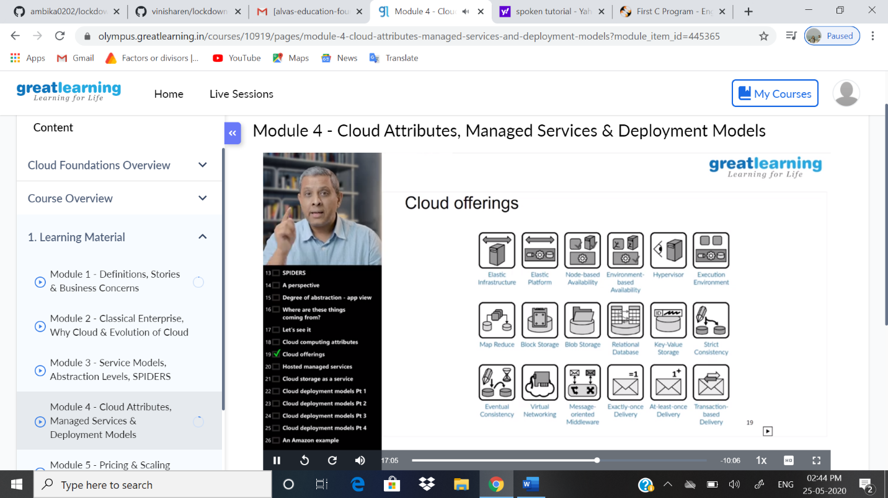

Coding Challenges Details: Problem statements: .

1. Write a C program to implement SRTF process scheduling.

Solution: Uploaded in github

Snapshot: